


FEATURED EMBEDDED SYSTEM PROJECT

Cellular and IP Audio System
ESP32-S3 / EC200U / W5500 / ESP-IDF / Android
Designed custom board revisions integrating cellular, Wi-Fi, Ethernet, USB, OLED, power control and modem level translation. Developed call-state handling and bidirectional PCM/I2S audio, WebSocket and UDP transport, and G.711/Opus integration work.
Refactored Arduino firmware into ESP-IDF tasks and modules. Added queue and jitter-buffer diagnostics, reconnect handling, audio test modes and Python host tools for prototype investigation.
Developed the Android app with AI assistance using Kotlin and Jetpack Compose for multi-device control, calls and SMS. Personally developed the server communication protocols, data and message management, and telecommunications logic.
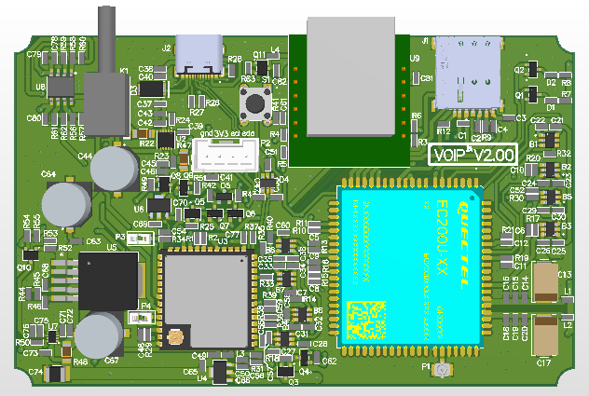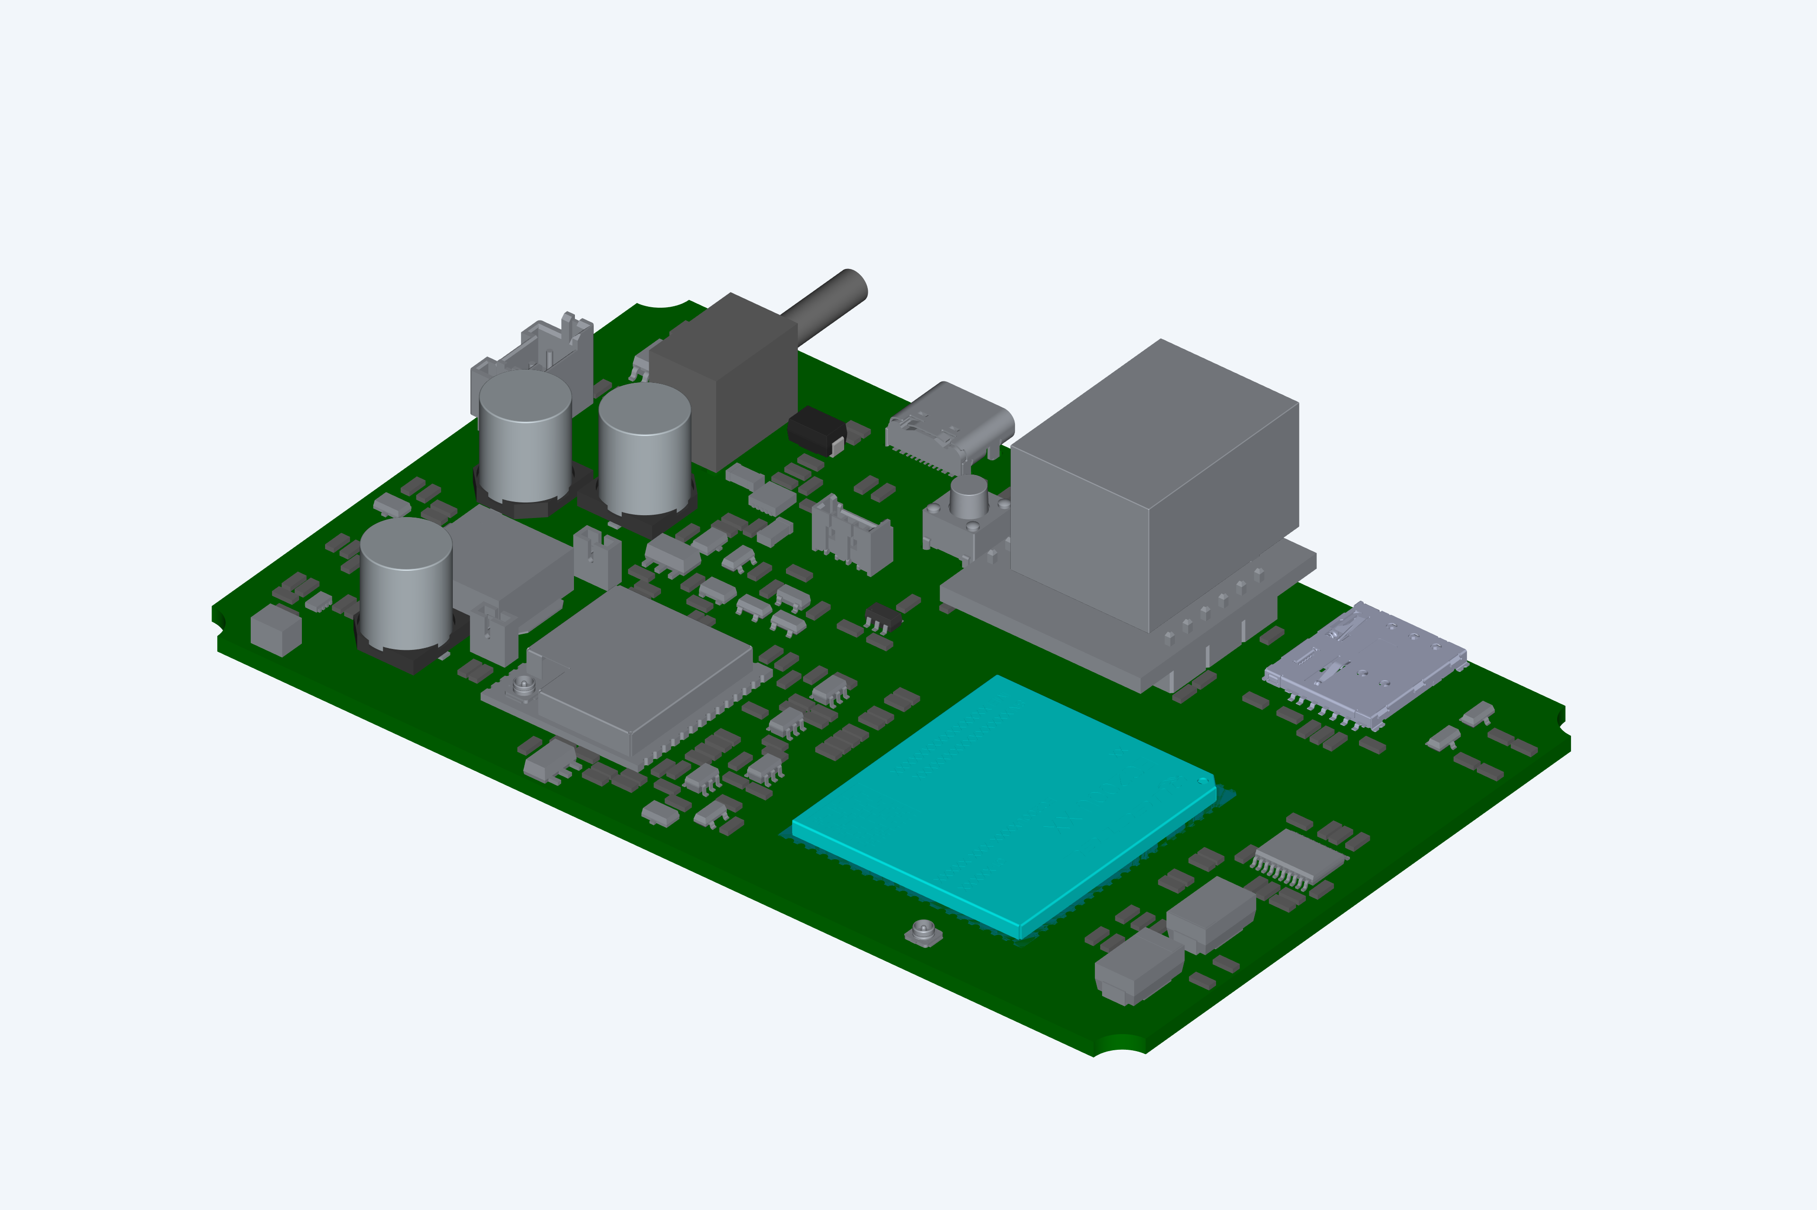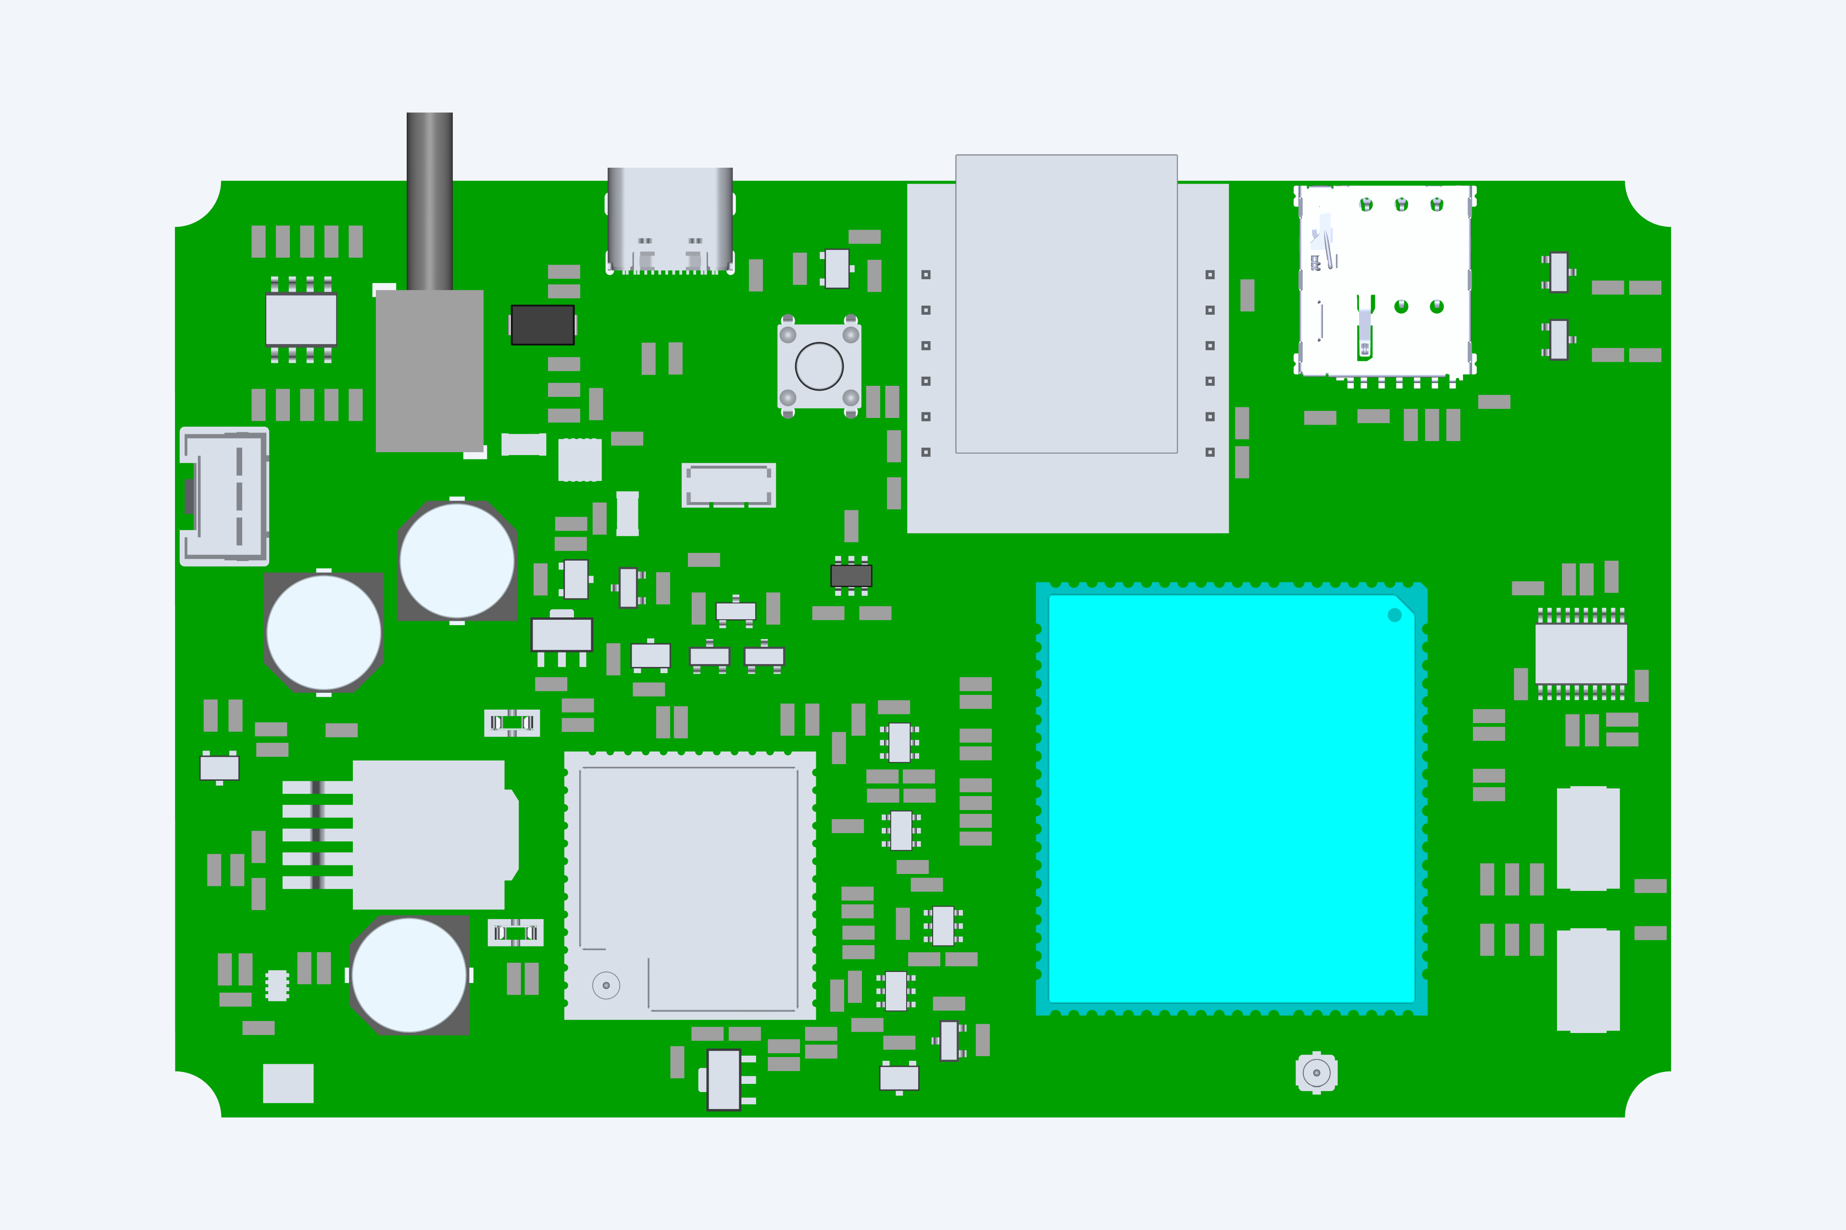
PCB CAD views: earlier V2.00 design and V2.01 perspective and top views
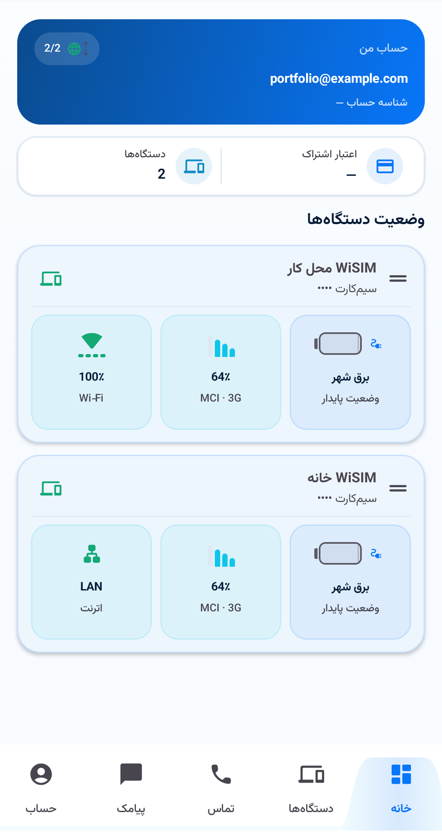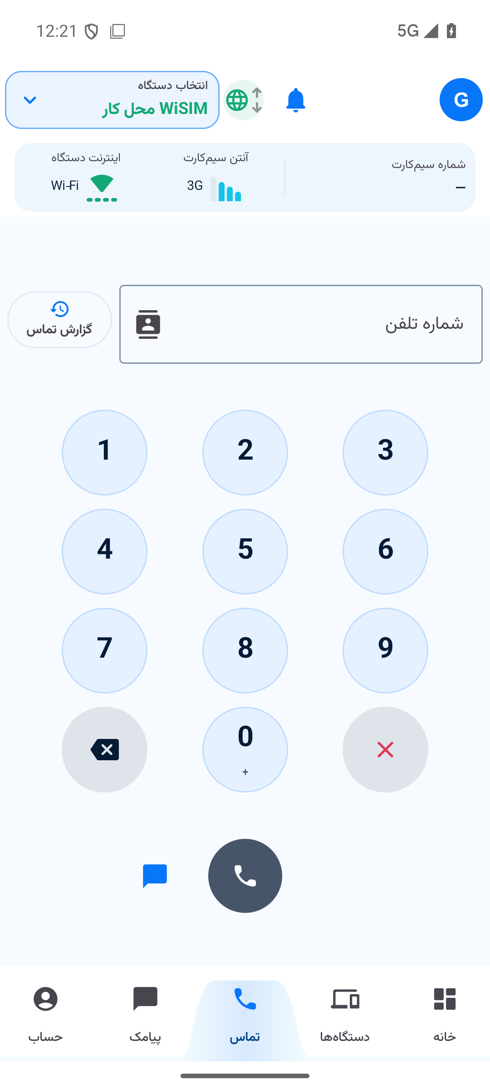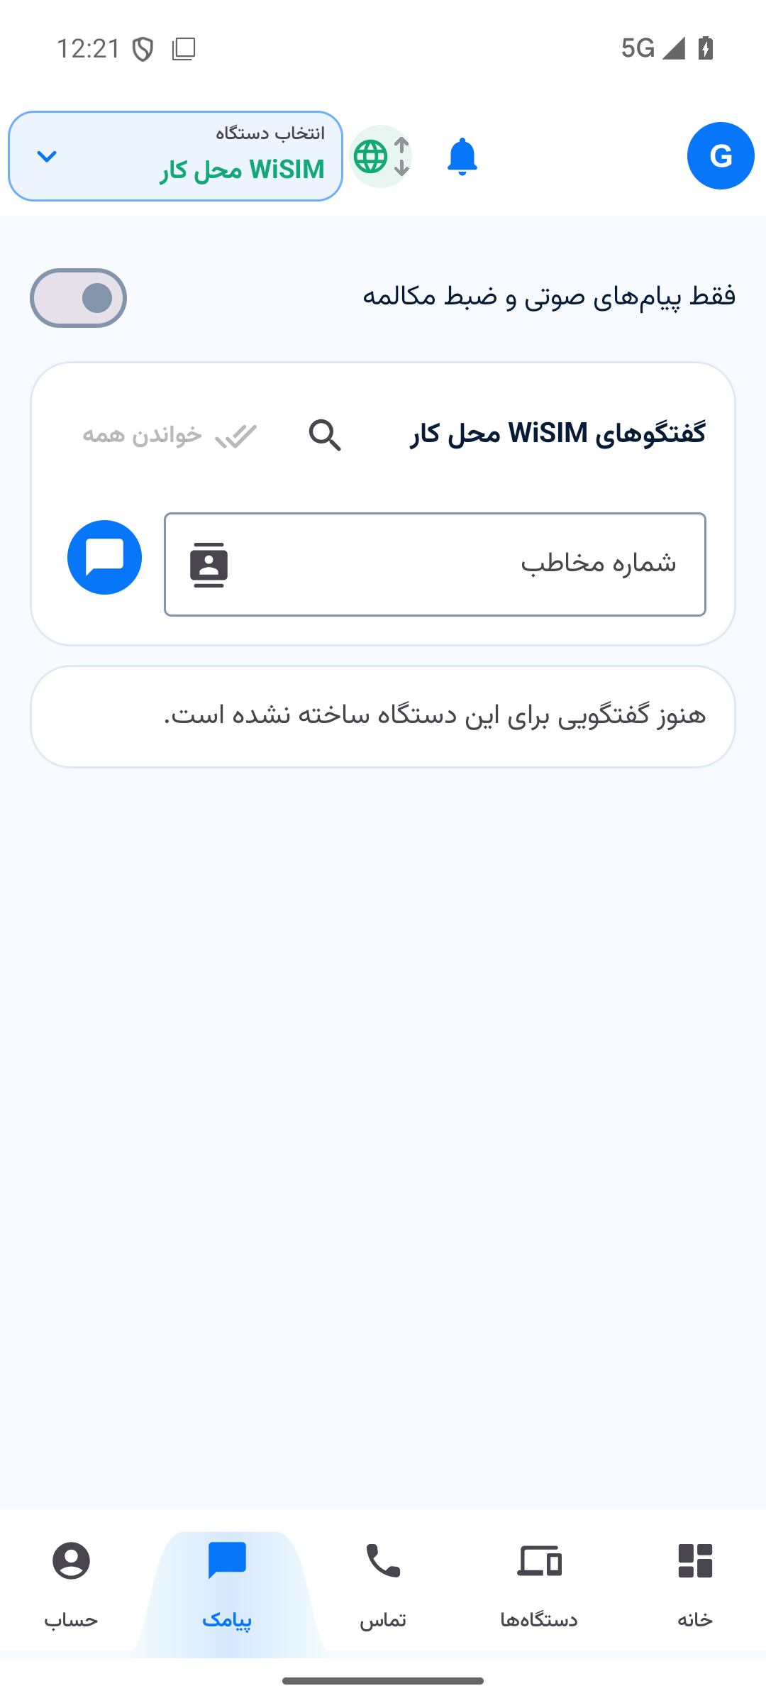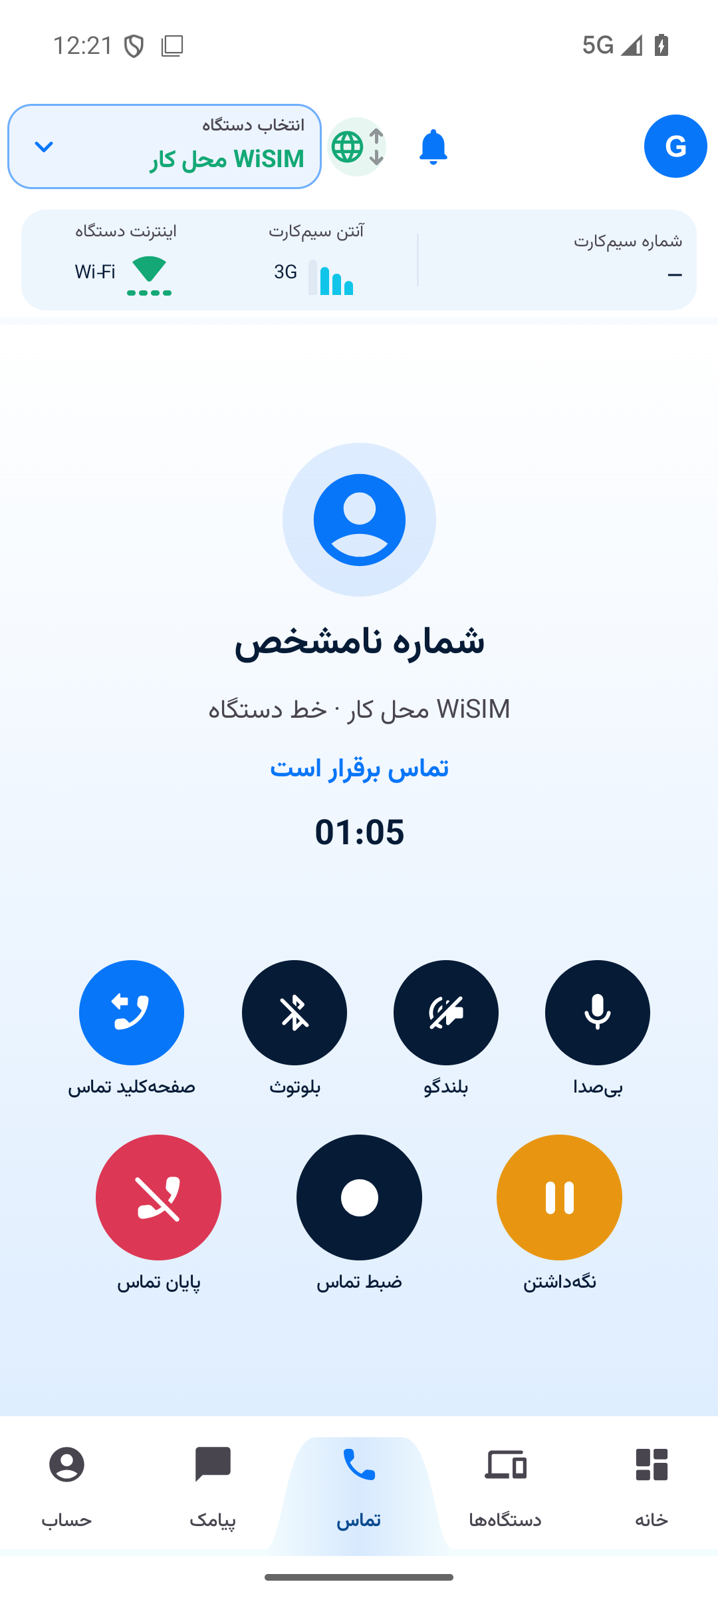
Android UI: device status, calls, messages and active call; demonstration data
EDUCATION
B.Sc. Biomedical Engineering
Bioelectric Engineering
Amirkabir University of Technology
Graduated 2022
GPA 16.52 / 20
EXPERIENCE
Current: independent
project work
Previously: WioTech R&D
3 years
PROJECT FOCUS
Embedded firmware
PCB and circuit design
Cellular and IP audio
Industrial control
Battery power systems
PORTFOLIO
lcenj.ir/about#portfolio
github.com/mnazizi
+98 930 897 4255
mohammadnorozianazizi
@gmail.com

PROFILE
Embedded Systems and Electronics Engineer working independently on client projects. Develop embedded products across circuit and PCB design, STM32 and ESP32 firmware, communication interfaces, hardware bring-up, and diagnostic software. Project experience spans cellular audio, industrial control, battery power systems, and connected devices.
CONTACT

MOHAMMAD NOROZIAN AZIZI
Embedded Systems and Electronics Engineer

AUDIO HARDWARE AND INDUSTRIAL CONTROL

SIP Audio Hardware
W5500 / PCM5102A / NS4165B / PoE / USB
Designed schematics and PCB hardware for Ethernet audio, including a DAC, speaker amplifier and embedded controller interfaces. Developed PoE and USB power circuits with source selection and reviewed component footprints.

GIFT Display Controller
ESP32-S3 / ILI9488 / 16-bit 8080 / USB-C
Designed a custom TFT controller board with a 16-bit parallel bus, control signals, series termination, backlight connections, dedicated display supplies, power switching, USB-C protection, button and buzzer interfaces.

Dual MCU Lock and Switching Controller
STM32F030 · ESP32-S3 · MPU6050 · UART · ESP-IDF · Embedded web UI
Developed separate STM32 and ESP32 firmware for actuator control, voltage sensing, motion monitoring, timing automation, and a browser-based control panel.
Implemented AES-CCM authenticated UART commands with replay rejection, persistent boot epochs, fault handling, and versioned release and integration-test records.
Added five-minute voltage history, time zoom, pause and review, and CSV export. Verified all 8,120 retained records, including 4,059 valid readings and explicitly marked unavailable slots, against the exported CSV.

Smart Car Wash Controller and IO Boards
STM32G070 · ESP32 · FreeRTOS · UART and RS-485 · Altium
Designed a board family covering central control, field IO, and operator panels, with isolated inputs and relay outputs for industrial equipment.
Developed STM32 peripheral and communication integration using UART DMA, RTOS tasks, I2C, and CRC support; integrated environmental monitoring and ESP32 connectivity.
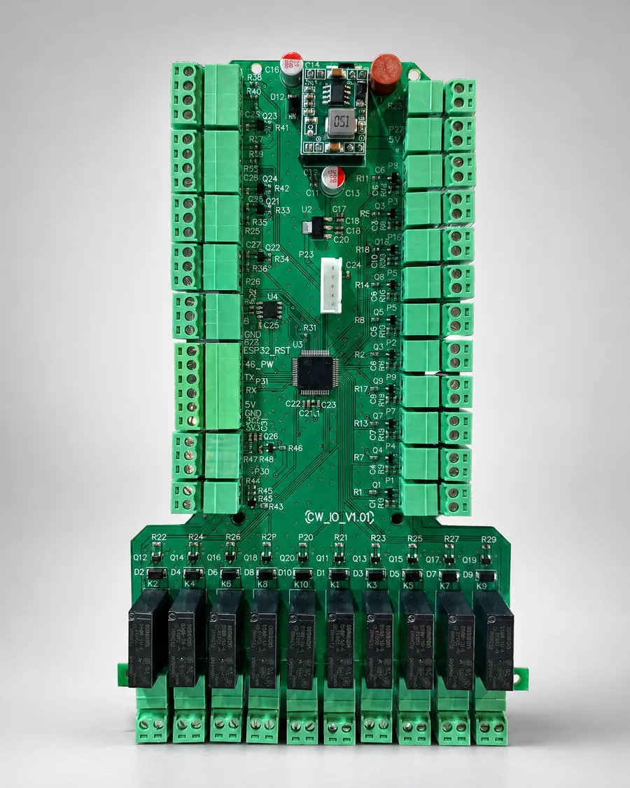
Car wash IO board: existing portfolio image
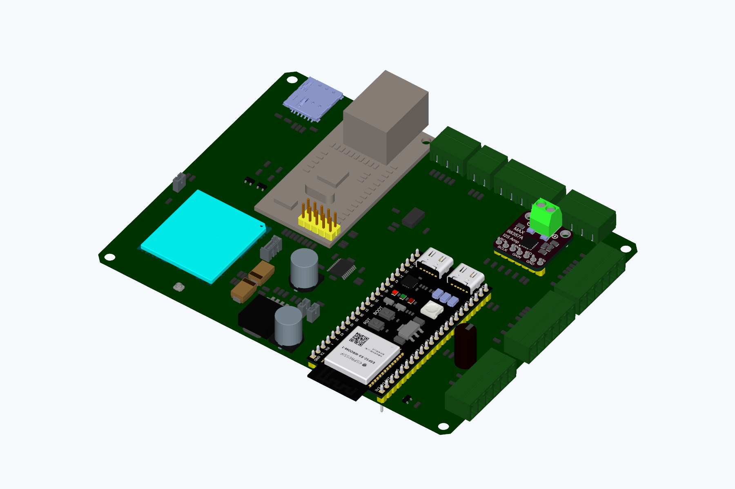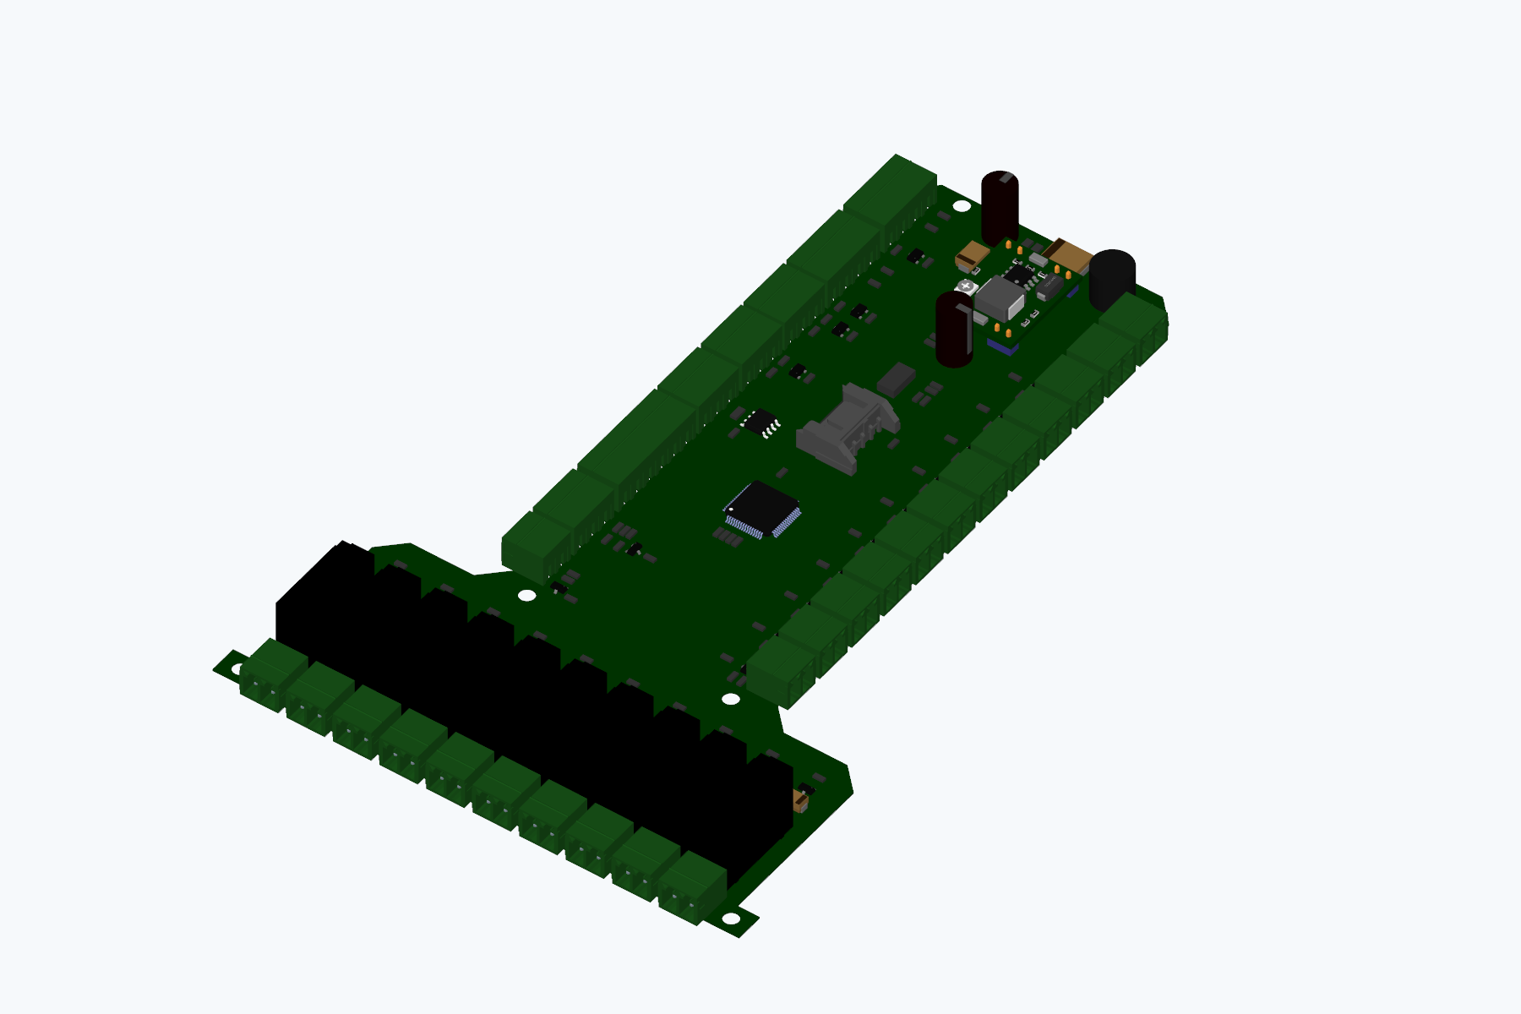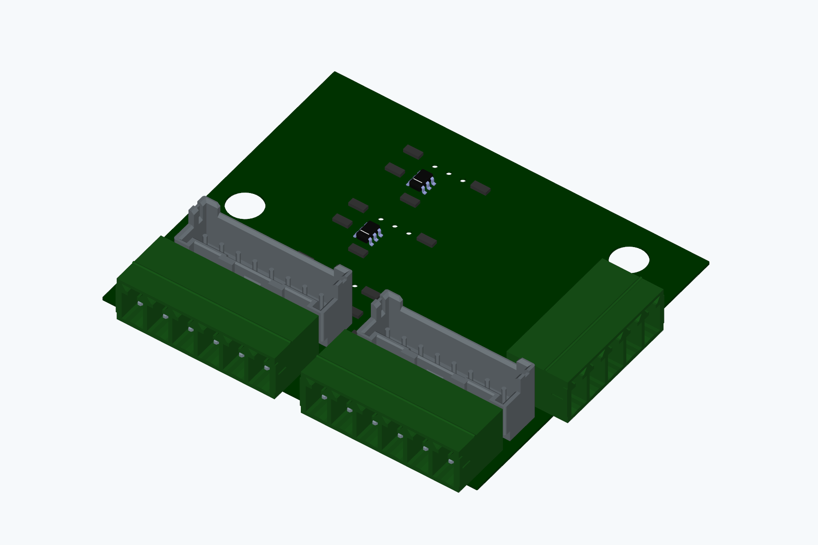
Controller, field IO and operator panel: renders from project STEP files

Four Channel LED PWM Controller
ESP32 · Arduino C++ · Wi-Fi web panel · NVS
Implemented four independent 5 kHz PWM outputs with programmable on and off intervals, brightness levels, and rise and fall transitions. Added a Persian web configuration panel and persistent settings.

POWER, SENSING AND EMBEDDED CONTROLLERS

Multiport Power Bank and Charging Hardware
STM32F030 · USB-C · IP5356 and IP5385 · BQ24610 · Altium
Designed multiple power-bank hardware revisions covering battery charging, USB-C power interfaces, power conversion, switching, protection, and MCU supervision.
Worked on architectures using IP5356/IP5385 power-management devices and BQ24610 charging circuitry, including a 24 V hardware variant and associated STM32 project configurations.
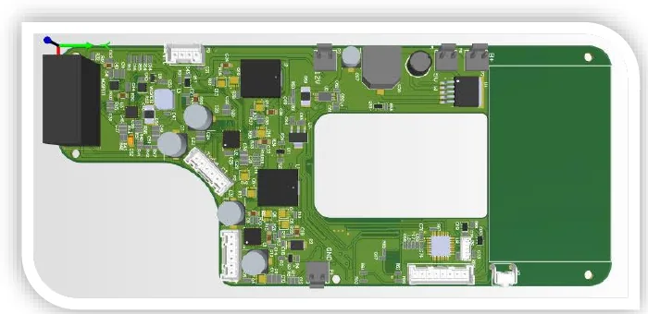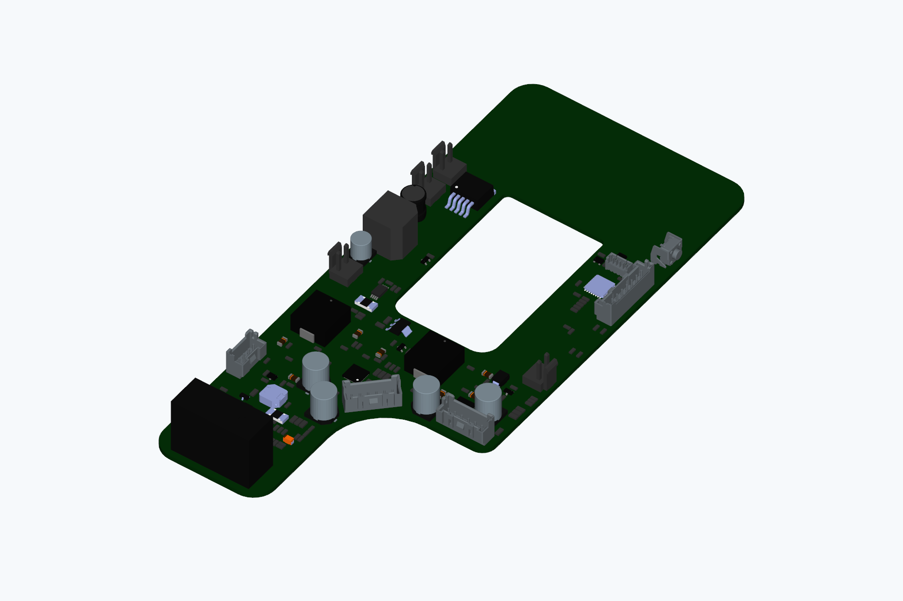
Power bank: previous CAD image and a render of the V1.1 STEP model

Temperature Monitoring and Embedded Interfaces
STM32 · Wireless modules · OLED and TFT · Altium
Designed hardware variants for wireless temperature logging and BLE modules. Worked on STM32 warmer-controller and display interfaces with temperature and time settings and sensor or overtemperature error states.
Developed additional circuit and interface designs for embedded power, relay cards with two to five channels, and STM32-based operator interfaces.
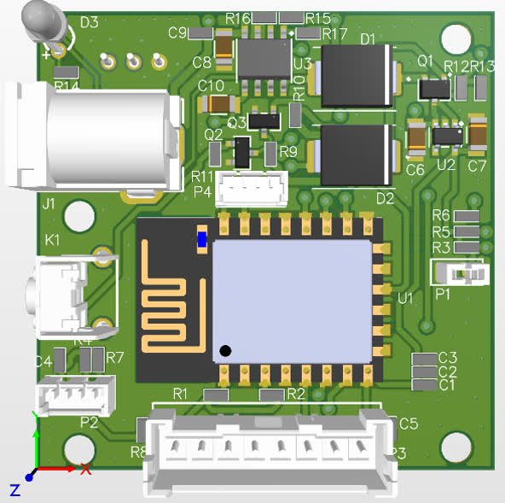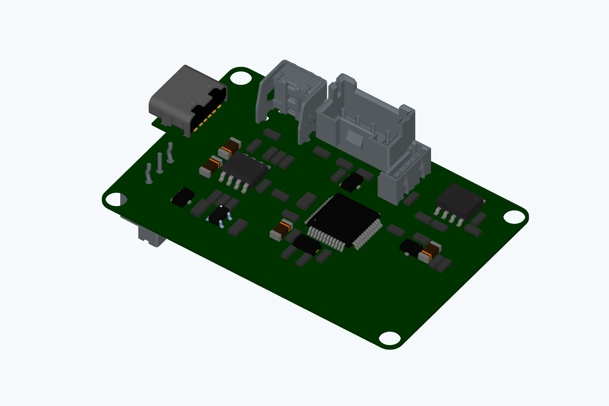
Temperature logger: previous PCB view and Bluetooth hardware STEP model

Gate and Jack Controller
STM32F103 · FreeRTOS · RF input · Keypad · OLED · EEPROM
Developed the embedded control structure for a dual-motor gate system, with motor-control tasks, open and close states, keypad and remote input, display support, and persistent settings interfaces.

Motion Sensing and BLE Air Mouse
ESP32-S3 · MPU6050 · BLE HID · ESP-IDF · Python
Implemented inertial sensor acquisition, BLE HID pointer output, calibration, stored screen mapping, and recovery after temporary I2C sensor disconnection.
Built a Windows sensor dashboard with live plots and CSV capture. A saved hardware test recorded 600 samples at 50 Hz, with BLE connected throughout and 599 HID reports.

ADDITIONAL EMBEDDED HARDWARE PORTFOLIO

Additional PCB Design Portfolio
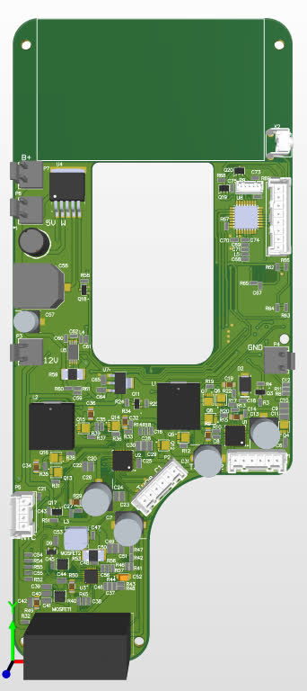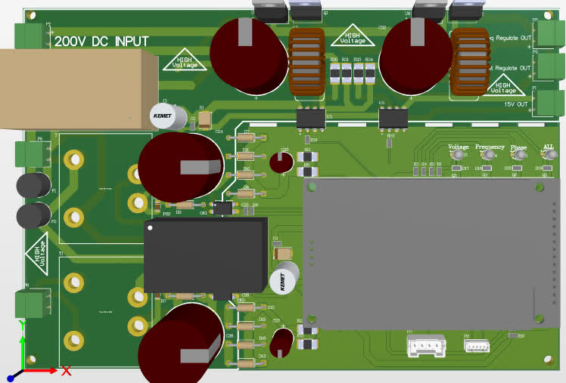
Battery-power and power-conversion PCB designs

WioSmart and WioFind Hardware Portfolio
Embedded electronics hardware designs from my previous WioTech collaboration, illustrated with the corresponding project STEP models.
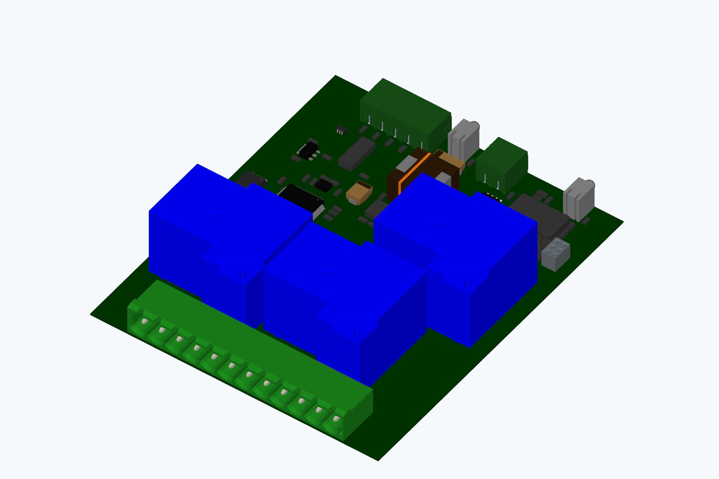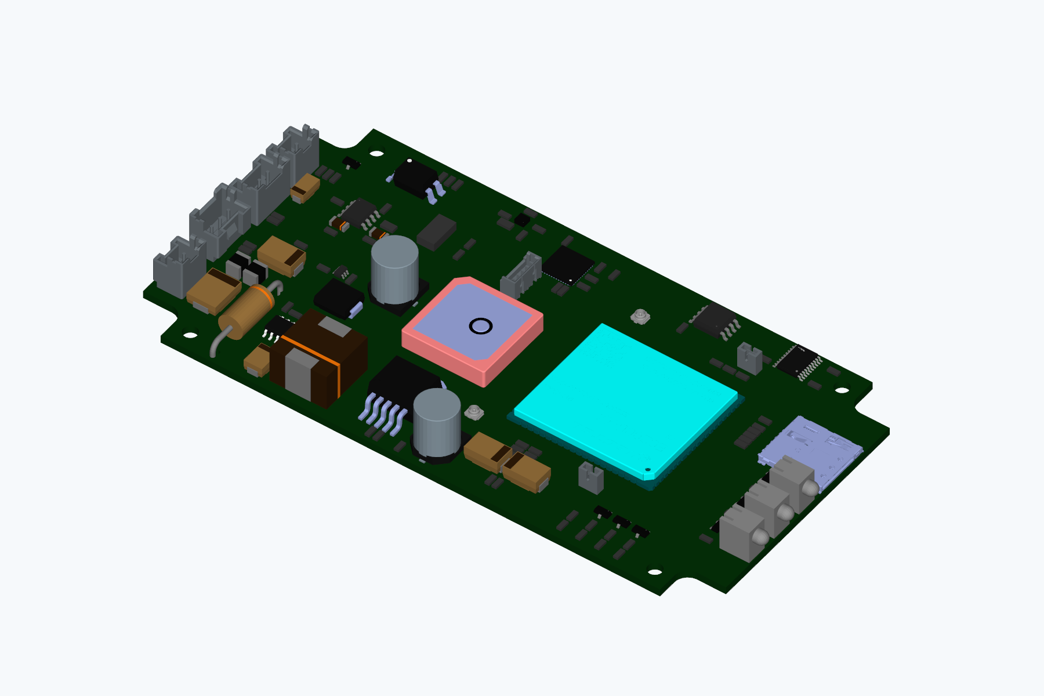
WioSmart I4 / WioFind T1

PROJECT DEMONSTRATED SKILLS
Firmware: C/C++, STM32 HAL, ESP-IDF, Arduino, FreeRTOS, RTOS tasks and queues, interrupts, DMA, ADC, timers, PWM, persistent settings, firmware updates.
Hardware: Altium Designer, schematics and PCB layout, component selection and footprints, power conversion and charging, protection, level shifting, Ethernet and audio interfaces.
Connectivity: UART, SPI, I2C, RS-485, PCM/I2S, Wi-Fi, BLE HID, cellular modems, TCP/UDP, WebSocket.
Engineering tools: Python diagnostics, CSV capture, serial logging, test reports, source and release organization.
Mobile: AI-assisted Android development, Kotlin, Jetpack Compose; personally developed server protocols, data and telecommunications logic.

